Requirements for the project webpage to be included at each implementing agency to disclose ESF documents and maintain the page functional and update during the project implementation.
Project Name: Rwanda Urban Development Project II-RUDP II | REPUBLIC OF RWANDA  LOCAL ADMINISTRATIVE ENTITIES DEVELOPMENT AGENCY (LODA)  IKIGO GISHINZWE GUTEZA IMBERE IBIKORWA BY’ITERAMBERE MU NZEGO Z’IBANZE  AGENCE DE DEVELOPPEMENT DES ENTITES ADMINISTRATIVES LOCALES  B.P: 7305 Kigali, Tel: 5029, web site: www.loda.gov.rw & E-mail: info@loda.gov.rw
Project Description (components, sub-components and activities:  The overall project development objective is to improve access to sustainable infrastructure and services, and strengthen urban management and resilience in low income areas in the City of Kigali and the 6 Secondary Cities (SCs) of Rwanda which are Nyagatare, Musanze, Rubavu, Rusizi, Huye and Muhanga. Activities under RUDP-II will be structured into three components namely, Support to the City of Kigali, Support to six secondary cities and Institutional Capacity Development and Project Management.  The component 1 has two subcomponents which are Subcomponent 1a: Integrated urban planning for resilient, inclusive infrastructure delivery in CoK and Subcomponent 1b: Evidence-based, sustainable wetland management, flood risk management and greenhouse gas monitoring in CoK. Activities of the subcomponent 1 include 4 urban upgrading of unplanned resettlements (civil works for road access, pedestrian walkways, and streetlights); flood infrastructure (hotspots); Storm water management master plan; Water level monitoring; Technical assistance (TA) for master plan implementation in Kigali and TA for CIP, revenue enhancement, expenditure management and innovative financing for wetland sustainability. Under the sub-component 1b, the sub-projects include wetland rehabilitation of Gikondo and Nyabugogo; LiDAR survey; GHG monitoring and reporting framework for CoK; advocacy, knowledge exchange and partnerships.  The 2 sub-components of the component 2 are Infrastructure and service delivery in secondary cities and Institutional capacity development of secondary cities. The sub-component 2a will comprise of phase 3 and 4 whose investments include the civil works for urban infrastructure (Asphalt roads; pedestrian walkways storm water drains; street lighting and bus stops). The subcomponent will also include TA for planning, design and supervision. The main sub-projects of the sub-component 2b are the provision of TA for master plan implementation and TA to support City Management Offices (CMOs) through institutional capacity development activities.  The last component of Institutional Capacity Development and Project Management has also two sub-components. Subcomponent 3a: Institutional capacity development at national level. The focus will be put on TA in roadmap establishment for the City Management Offices (CMOs) development; TA for implementation and monitoring of national urbanization policy and TA for lessons learned of upgrading pilots (such Agatare) and developing guidelines for urban upgrading. Moreover, the subcomponent will provide TA for strategy development of sites and services for urban development; TA for national solid waste management strategy, feasibility studies for disposal facilities in 6 SCs. The subcomponent 3b of the project management will include the budget allocated to the implementing agencies/ institutions at MININFRA PCU, CoK KUUT, LODA SPIU, and District PIUs for the project management and budget for Resettlement and compensation costs. | 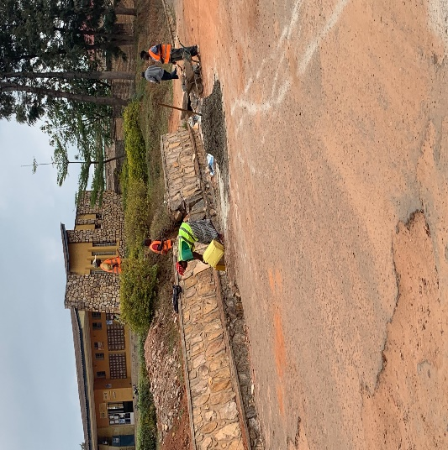  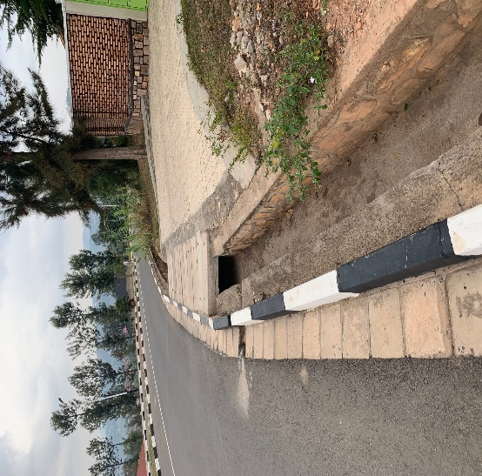  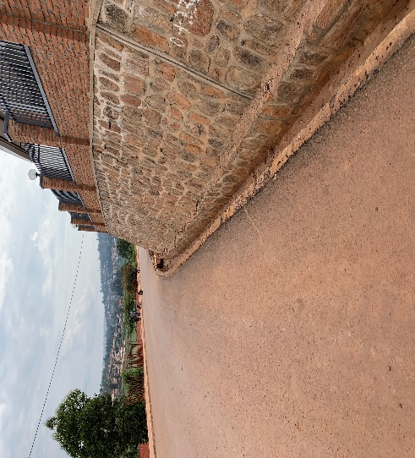  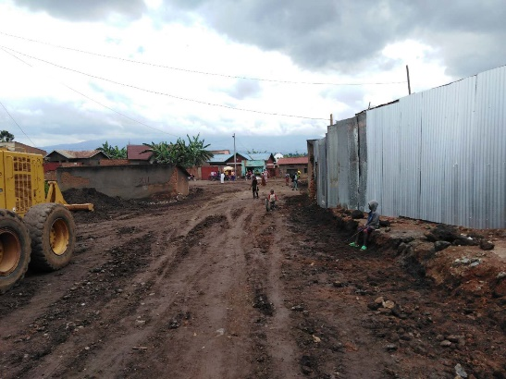  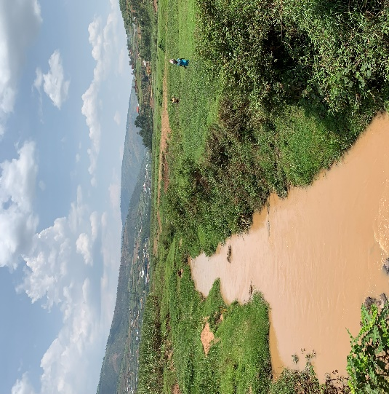
Environmental and Social Management of the project
The RUDP II environmental rating is “Substantial” because of the following main reasons: large number of civil works dispersed in 7 cities in populated urban areas; limited experience of the districts in the application of the new Environmental and Social Framework (ESF) and the high coordination that will be needed for proper supervision, high number of stakeholders that will be affected; challenges to manage a large number of contractors and workers in different cities and at the same time to supervise compliance of the ESF instruments and cumulative impacts local residents will experience within a community. Potential impacts include (i) disruption of normal life in populated areas, ii) damages in public services (roads, water services, bus stations, access to schools, homes, etc. in unknown period of time), iii) waste generated at construction sites which can pollute land and water bodies (cement mixing areas, metal, wood and paint residues, diesel and other residues); iv) excavations, open ditches and slope cutting over long periods which can cause accidents to local residents; (v) cutting of slopes and sedimentation of streets, drainage, (vi) cutting of trees and damage to vegetation when debris or soils are pushed in slopes edges and (vii) road accidents among others. It is envisaged that the management of those project-related environmental and social impacts and many others will require application and compliance with the ESF documents: ESMF, RPF, LMP, SEP and ESCP.

ESMF: The Environmental and Social Management Framework (ESMF) was prepared following the World Bank requirements of the Environmental and Social Standards (ESSs) and it is a mandatory document for the project implementing units, to ensure any work to be financed by the Bank is first assessed in terms of potential environmental and social impacts and risks. The main purpose of the ESMF is therefore to avoid, minimize adverse social and environmental impacts. Of the 10 ESSs, only 8 are relevant to RUDP- II. These are: ESS1: Assessment and Management of Environmental and Social Risks and Impacts; ESS2: Labor and Working Conditions; ESS3: Resource Efficiency and Pollution Prevention and Management; ESS4: Community Health and Safety; ESS5: Land Acquisition, Restrictions on Land Use and Involuntary Resettlement; ESS6: Biodiversity Conservation and Sustainable Management of Living Natural Resources; ESS8: Cultural Heritage and ESS10: Stakeholder Engagement and Information Disclosure. The ESMF has defined the requirements for ESIA development for the proposed urban infrastructure and wetland rehabilitation sub-projects and investments under the RUDP II in compliance with relevant laws of Rwanda and the ESF of the World Bank. All project investments are subject to the application of the relevant ESSs agreed with the World Bank. The ESMF further defined the procedure to be followed by all units in the proposed RUDP II components/sub-projects and in the six secondary cities and CoK in order to comply with relevant ESSs. This ESMF has been prepared as a mandatory manual for all implementers of the RUDP-II which include the Ministry of Infrastructure (MININFRA), City of Kigali (CoK), Local Administrative Entities Development Agency (LODA), Rwanda Environment Management Authority (REMA), 6 targeted Secondary Cities, Consultants, Contractors and Subcontractors.

RPF: In accordance with the WB’s ESS5, this document is a policy framework developed by the GoR to clarify resettlement principles, organizational arrangements, and design criteria to be applied to subprojects to be prepared during the implementation of urban infrastructure under this project. The RF includes brief description of the project and project components; a description of the anticipated subproject types and their locations; the programme implementation arrangements; details of the project and project components for which land for resettlement is required; the principles and objectives governing resettlement preparation and implementation; a description of the process for preparing and approving resettlement plans; census of the population that will be affected and or displaced by the project and likely categories of affected/displaced persons, to the extent feasible; eligibility criteria for defining various categories of affected persons; gap analysis of the fit between Rwanda laws and GoR policies and regulations and World Bank’s ESF requirements including measures proposed to bridge any gaps between them; detailed methods of valuing affected assets; organizational procedures for delivery of entitlements by the government; a description of the implementation process, linking resettlement implementation to civil works; a description of grievance redress mechanisms; a description of the arrangements for funding resettlement, including the preparation and review of cost estimates, the flow of funds, and contingency arrangements; a description of mechanisms for consultations with, and participation of, displaced persons in planning, implementation, and monitoring; and arrangements for monitoring by the implementing agency and or independent monitors.

SEP: In accordance with ESS10 of the WB’s ESF, the SEP for RUDP-II is a formal strategy to provide equal opportunities for engagement and participation to the affected, interested, concerned stakeholders to be on the project and to define effective communication strategies with the different project stakeholders. The SPE will be an operational tool to define the protocols for effectively engaging local and affected communities in the overall project development, disseminate activities, outputs and results, coordinate and hold consultations and develop clear channels of communication of the project to all relevant stakeholders and target audience. The SEP will also describe the agreed Grievance Mechanisms that will be available for affected/interested/citizen of Rwanda for sending claims, observations, and request to the project team.

LMP: The Labor Management Procedures has been prepared by the Government of Rwanda as part of requirements of ESS2 of the WB’s ESF with the aim to set up the mandatory procedures to be followed in the implementation of the RUDP II project interventions in relation to labor, health and safety, among other topics. The agreements, protocols and procedures here described are mandatory for the implementation of RUDP -II, thus all team members hired and assigned to work in the project will have to become familiar with this document and ensure its application during the project lifetime (5 years).
The LMP defines the Labor Management procedures as required by the Environmental and Social Framework of the World Bank, and its Environmental and Social Standard 2 which scope includes:
1-Labor and contracts
2-Management of workers
3-Ocuppactional Health and Safety
4-Accces of information and grievances mechanisms

ESCP: The ESCP contains all the commitments made by the GoR vis a vis the protection of the environment and preservation of the social welfare of the Project Affected People. The Governments has made commitments against each one of the 8 ESSs that concern RUDP as above described. The ESCP contains as well information on budgets to be allocated to different activities that will be implemented as part of the environment protection and preservation of social welfare including health and safety, labor, training, stakeholders engagement and GRM.

Please place all ESF documents prepared and cleared by the WB – with complete names first as draft- after consultation as final documents. Place attached them as PDF and the option for people to download or read.
-ESFM, RPF, SEP, LMP, ESCP
Online consultation  The project needs to have a public consultation of the documents and invites readers to send comments  Place a date for at least 1 week to receive comments for the appraisal  Insert Window for sending comments, observations to the ESF documents | Contact person  -Environmental Specialist:  Habineza Alphonse  E-mail: habiaalpha@gmail.com or alphonse.habineza@loda.gov.rw,  Tel: (+250)788-816-695  -Social Safeguard Specialist:  Email: apophia.boramungu@loda.gov.rw  Tel: +250 782537195

