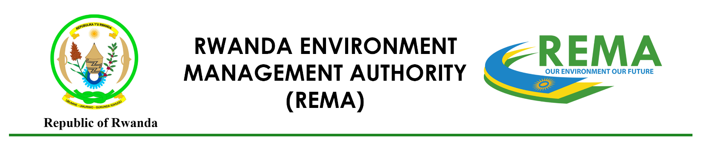

Project Idea Note on Climate Finance Training

Title of the project
Applicant’s name & Address
Sector(s), select all that are applicable | ☐ Climate Change Mitigation project development (Energy, Transport, Buildings & Cities, Forests and Land-use etc.)  ☐ Climate Change Adaptation and Resilience project development (Ecosystem and Ecosystem services, Livelihoods of people and communities, infrastructure and built environment, Health, Food and Water security)  ☐ Cross-sectoral approach with Gender, safeguards and social inclusion
Project Purpose
Provide brief summary of the problem statement and climate rationale and objective (max 50 words)
Context and baseline
Please indicate how the project fits in with the country’s national priorities, how it is contributing to the NDC;

Explain the main root causes and causes that need to be addressed

Why do we need to do the project? What is the impact of not doing the project?
Project description
Describe the expected set of components/outputs and activities to address the above barriers identified that will lead to the expected outcomes

Estimated duration of project

Main government counterpart

Total budget
Detailed budget per activities/subcomponents (Optional)

